

# ESP-32 BASED WATER TANK PROJECT

## PROJECT EXPLANATION REPORT

prepared for   
Michelin Lanka (Pvt) Ltd.

prepared by   
ENG. MILAN HARSHA KUMARA

Mr. J.C.B. Kehelwattha

Mr. P.D.N.D. SILVA

PROJECT OVERVIEW

The project focuses on modernizing the traditional electrical panel board of water tank by integrating advanced ESP-32 based electronic controller. The conventional panel boards have limitations in terms of efficiency, safety, and functionality. By transitioning to electronic controllers, we aim to enhance the management, monitoring, and control of water tank systems, ultimately improving user experience and resource utilization.

**For more details**: <https://github.com/SEUintern/ESP32_Water_Tank_Control>

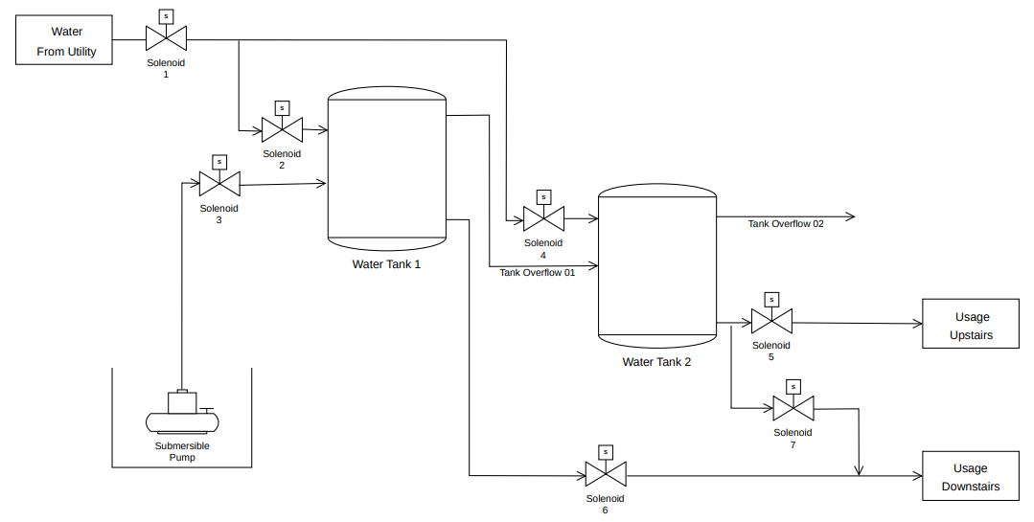

Figure 1: Proposed project diagram

KEY FEATURES

1. **Remote Monitoring and Control:** The ESP-32 electronic controller enables remote monitoring and control of water tank systems via a user-friendly interface. Users can access real-time data on water levels, valve positions, and other parameters from anywhere using connected devices such as smartphones or computers.
2. **Automation and Optimization:** The controller facilitates automation of water management tasks, such as pump operation and tank refilling, based on predefined parameters and schedules. This automation helps optimize water usage, reduce energy consumption, and minimize manual intervention.
3. **Safety and Security:** The controller eliminates the need for outdated panel boards with lack integrated safety mechanisms, increasing the risk of electrical faults, leaks, and other hazardous incidents.
4. **Fault Detection and Diagnostics:** The system enables the ability to integrate alert system with AI, so the users get alerts for potential issues or abnormalities in the water tank system. Advanced diagnostics tools help identify the root cause of problems, enabling timely maintenance and repairs. [Learn more](https://www.hivemq.com/sb-assets/f/243938/x/87f52b8720/webinar-slides-unleashing-power-of-ai-iot-hivemq-cloud-influxdb.pdf)
5. **Integration with IoT Ecosystem**: The new electronic controller seamlessly integrates with IoT (Internet of Things) ecosystems, allowing for interoperability with other smart devices and systems. This integration enables advanced functionalities such as data analytics, predictive maintenance, and smart home automation.

### BENEFITS

### **1. Enhance controllability (More Controllable Parameters)**

The transition to electronic controllers expands the system's control capabilities, allowing for precise management of various parameters like valve position, Motor status, water level with time. This precision enhances system performance and adaptability to changing needs.

**2. Lower weight and size (Reduced Size and Weight)**

Electronic controllers offer a compact and lightweight alternative to traditional panel boards, saving space and simplifying installation and maintenance processes.

**3. More Flexibility (Easy to accommodate changes)**

Electronic controllers provide flexibility to adjust to evolving requirements by enabling easy reconfiguration and expansion. This versatility ensures the system remains adaptable and effective over time.

**4. Lower Running cost (lower energy consumption and maintenance requirements)**

Electronic controllers are more energy-efficient and require less maintenance compared to traditional systems, resulting in significant cost savings over time. This lowers utility bills and reduces downtime and repair expenses.

### CURRENT STATE

As of 15th May 2024, the project has completed simulation activities to validate the feasibility and functionality of the ESP-32 based electronic controller. The simulation phase involved testing the controller's performance in virtual environments to ensure compatibility with existing electrical panel boards and desired functionalities. While the simulation results are promising, further validation is pending until the arrival of prototype equipment.PRE-STUDY AREAS

Before initiating the simulation phase, the project conducted thorough pre-study activities to lay the groundwork for successful implementation.

Key pre-study areas included,

1. **Technology Assessment**

* Evaluated the suitability of ESP-32 controllers for water tank management applications.
* Assess their technical specifications, capabilities, and compatibility with existing infrastructure by studying datasheets, technical documentation, and case studies. [Learn more](https://github.com/SEUintern/ESP32_Water_Tank_Control/blob/main/Documentation/Project%20Charter%20-%20Esp%2032%20Based%20Water%20Tank%20Project.pdf)

1. **Regulatory Compliance**

* Investigated regulatory requirements and standards applicable to water tank management systems to ensure compliance with safety, environmental, and industry regulations. [Learn more](https://github.com/SEUintern/ESP32_Water_Tank_Control/tree/main)
* Source electronic controllers from reputable manufacturers.

1. **Risk Analysis**

* Conducted a comprehensive risk analysis to identify potential challenges, obstacles, and uncertainties that could impact project execution.
* Learn how to develop risk mitigation strategies and contingency plans to minimize project risks. [Learn more](https://github.com/SEUintern/ESP32_Water_Tank_Control/blob/main/Documentation/Project%20Proposal-%20Esp%2032%20Based%20Water%20Tank%20Project.pdf)

1. **Mobile Application Development**

* Study ActionScript programming languages.
* Gather basic knowledge in UI and UX designing.
* Familiar with Kodular.io platform. [Learn more](https://www.kodular.io/)

1. **Microcontroller Programming and simulating**

* Dive deeper into microcontroller programming languages such as C++, Micro-Python and explore advanced programming techniques for efficient utilization of resources, optimization of code execution, and real-time responsiveness. [Learn more](https://docs.micropython.org/en/latest/esp32/tutorial/intro.html)
* Familiar with wokwi.com platform and circuit simulations. [Learn more](https://wokwi.com/esp32)

1. **Wireless Communication Protocols**

* Study MQTT wireless communication protocol for reliable and low-power communication between devices, ensuring seamless connectivity in diverse environments. [Learn more](https://www.hivemq.com/mqtt/mqtt-5/)
* Monitor project progress and performance metrics.

1. **Advanced Control Algorithms**

* Conduct research on advanced control algorithms to further optimize water tank operations for efficiency and resource utilization.

### **EXPERIENCE GAINED AND LEARNED LESSONS**

**1. Technical Proficiency**

In-depth technical knowledge and proficiency in working with ESP-32 based electronic controllers, sensor integration, and communication protocols.

**2. Project Management**

Experience in coordinating and executing simulation activities enhanced project management skills, including task prioritization, resource allocation, and timeline management.

**3. Importance of Early Testing**

Early testing in virtual environments allowed for the identification of potential issues and areas for improvement before the prototype stage, saving time and resources.

**4. Need for Iterative Development**

The iterative development approach proved beneficial in refining the electronic controller's functionalities based on feedback from simulation testing, highlighting the importance of continuous improvement throughout the project lifecycle.

**5. Emphasis on Real-world Validation**

While simulation testing provides valuable insights, real-world validation remains crucial to confirm the electronic controller's performance and functionality in practical scenarios.

### **NEXT STEPS**

**1. Prototype Equipment Arrival**

Waiting for the arrival of prototype equipment, including the ESP-32 based electronic controllers and associated hardware components.

**2. Physical Testing and Validation**

Conducting physical testing and validation of the prototype equipment in real-world water tank systems to confirm performance and functionality.

**3. Iterative Development**

Iterative development and refinement based on feedback from physical testing to further enhance the reliability and effectiveness of the electronic controller.

**4. Project Implementation**

Assembling the finale controller with industrial graded equipment and conducting the training of the staff for the operating and maintenance.

### CONCLUSION

The completion of the 1st phase (simulation) marks a significant milestone in the project's progress. It shows the project's commitment to digitalize water tank electrical panel boards with advanced electronic controllers. With promising simulation results and further validation pending upon the arrival of prototype equipment, the project remains on track to achieve its objectives of improving water tank system management, monitoring, and control.